39.35: 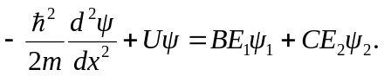
If were a solution with energy E, then
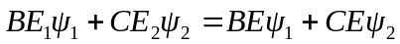 or
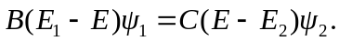
This would mean that 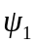 is a constant multiple of 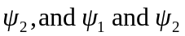 would be wave functions with the same energy. However, 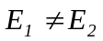, so this is not possible, and cannot be a solution to Eq. (39.18).

